Published by | Editor

HEWI
Marketing + Innovation

HEWI Heinrich Wilke GmbH
P.O. box 1260
D-34442 Bad Arolsen
Phone: +49 5691 82-0
presse@hewi.de
www.hewi.com

Reprint free - specimen copy requested

Range 270
Architecture in Miniature
The architect and product designer Hadi Teherani has an holistic approach to architecture. His work doesn’t end with the design of the architectural space. . Hadi Teherani has made it his task to charge space with atmosphere. The architecture provides the basic structure for the design idea and manifests itself down to the smallest detail. The linking of the disciplines becomes particularly clear in the product design.
Architectural elegance therefore characterises the Range 270 designed by Hadi Teherani. The style displays its demeanour through its deliberately chosen purist design. Clear edges and geometric lines are almost reminiscent of his architecture.
Minimalism in its purest form: The design is reduced to the essentials and consistently reflects the design of the HEWI mini-rose. The lever handle and rose harmonise perfectly. Matt-sanded stainless steel underscores the classic design. Series 270 stands out thanks to the high level of quality and production-related precision. The new HEWI fittings range is the perfect result of design, technology and quality.
The attachment equipment fulfils the requirements of user category 4 according to EN 1906 and is suitable for private homes and also heavily-frequented office and commercial buildings.

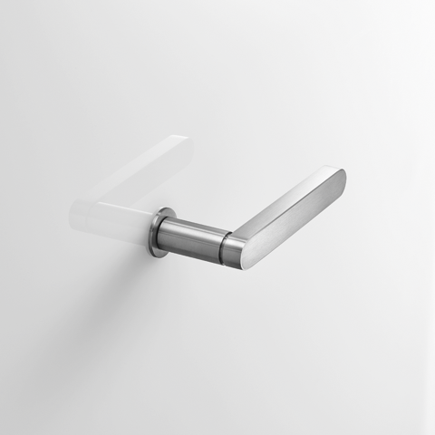
Range 270

